How to Install Extension.

1. Extract “Link Extract” to a safe location 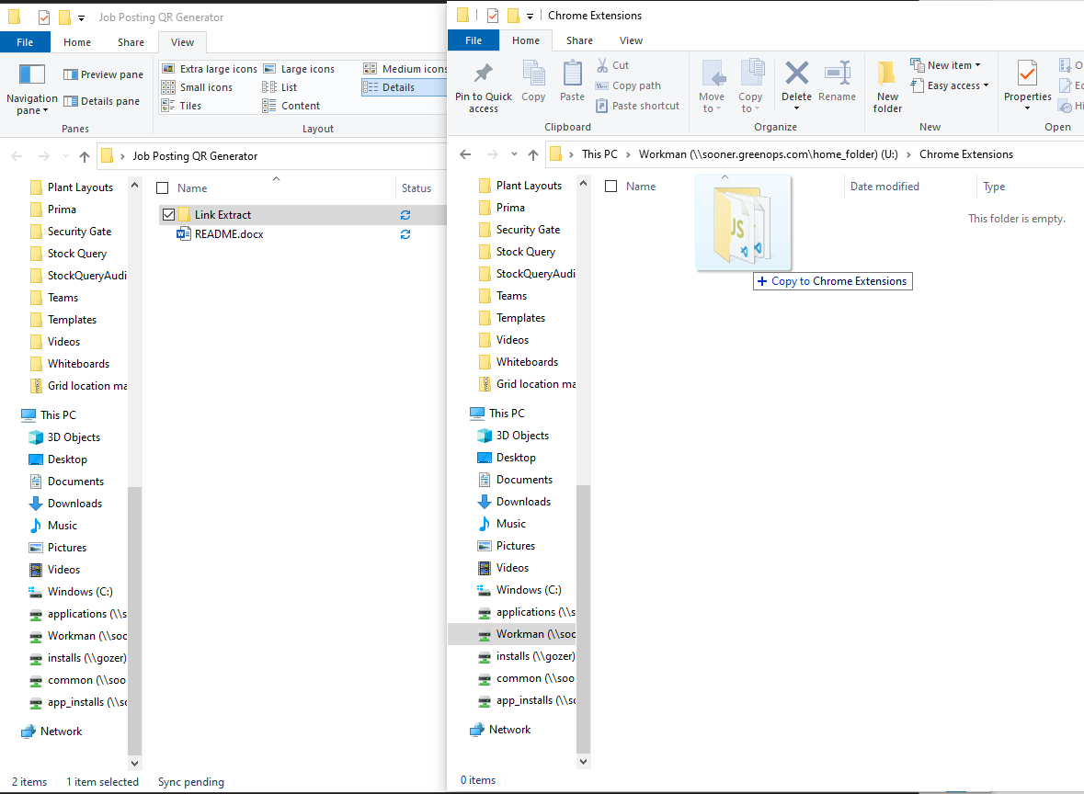
2. 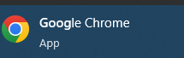Open Chrome

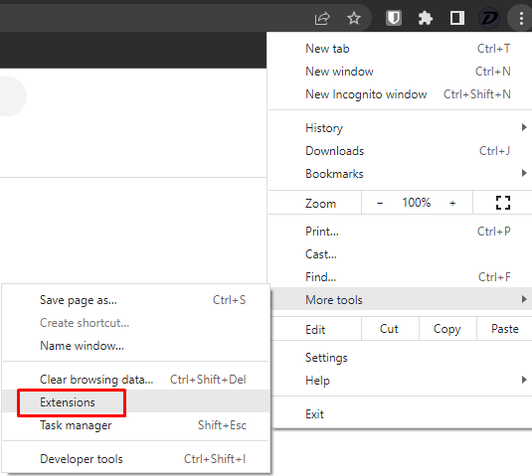

1. In top-right corner of Chrome, open hamburger menu then mouse mouse over More tools and click Extensions.
2. 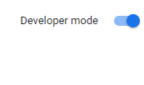In top right of extension web page, enable developer mode.



1. Click Load Unpacked

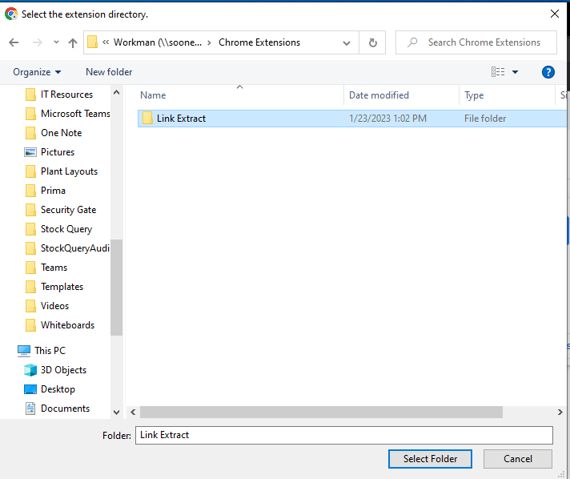

1. Navigate to where you saved Link Extract and click I then click “Select Folder”
2. 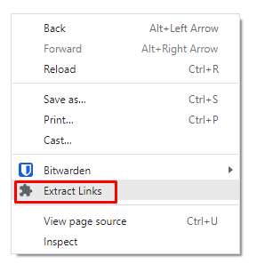After a moment the extension will be installed and a new option will appear in your right-click menu. This is how you use the extension.